Final Report for the
Workshop for Applied Nuclear Data Activities
January 22-24, 2019
George Washington University
Washington, DC

Contributions from Lee Bernstein¹, Catherine Romano², D.A. Brown³,
Robert Casperson⁴, Marie-Anne Descalle⁴, Matthew Devlin⁵, Chris Pickett²,
Brad Rearden² and Cristiaan Vermeuelen⁵

¹Lawrence Berkeley National Laboratory/U.C.-Berkeley
²Oak Ridge National Laboratory
³National Nuclear Data Center/Brookhaven National Lab
⁴Lawrence Livermore National Laboratory
⁵Los Alamos National Laboratory

LLNL-PROC-769849

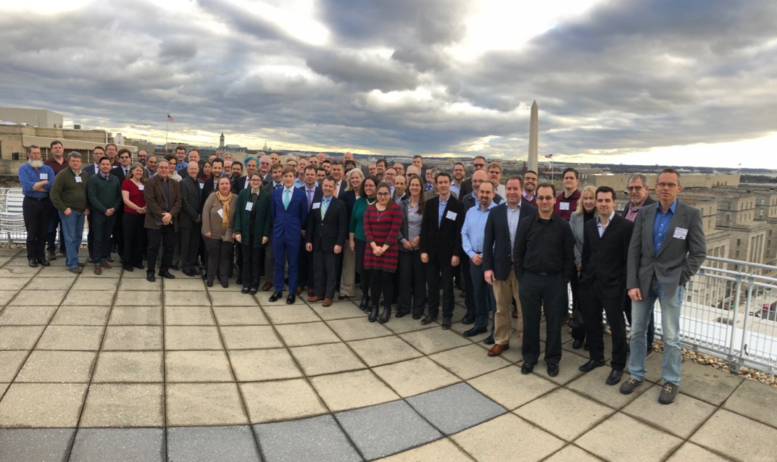

Introduction 4
WANDA Timetable 7
Tuesday 22 January 2019 – Opening Plenary Session 7
Wednesday 23 January 2019 12
Roadmapping Session 1A: Nuclear Energy - Lindner Family Commons (08:30-10:00) 12
Roadmapping Session 1B: Isotope Production - State Room (08:30-10:00) 12
Roadmapping Session 1A (continued): Nuclear Energy - Lindner Family Commons (10:20-12:00) 12
Roadmapping Session 1B (continued): Isotope Production - State Room (10:20-12:00) 13
Roadmapping Session 2A - Materials Damage - State Room (13:15-14:55) 13
Roadmapping Session 2B - Safeguards: - Program manager perspective User Input - Lindner Family Commons (13:15-14:55) 13
Roadmapping Session 2A (continued): Materials Damage - State Room (15:15-17:00) 15
Roadmapping Session 2B - Safeguards: Roadmapping Session 2B - Safeguards - Linder Family Commons (15:15-17:00) 15
Thursday 24 January 2019 16
Roadmapping Session 3A: (n,x) reactions - City View (08:30-10:00) 16
Roadmapping Session 3B: Atomic, XRF Data - State Room (08:30-10:00) 16
Roadmapping Session 3A (continued) : (n,x) reactions - City View (10:20-12:00) 18
Roadmapping Session 3B (continued): Atomic, XRF Data - State Room (10:20-12:00) 18
Presentation of Key Outcomes - City View (13:30-15:45) 18
Q&A and Closeout - City View (16:00-17:00) 18
Summary of WANDA session on (n,x) reactions 19
Introduction 19
Prioritized Plan: 20
Roadmapping Session 1B: Isotope Production 21
Session Highlights 22
Conclusion 24
Safeguards 25
Session Agenda: 25
Introduction 25
Destructive analysis for Material Control & Accountability (MC&A) and Safeguards 28
Nuclear and Atomic Data Needs for Nondestructive Data Analysis (NDA) Measurements and Metrology in Nuclear Safeguards 29
Breakout Session Discussion Comments: 32
Materials Damage and Gas Production Cross Sections 35
Session Summary 35
Suggested Solutions and Proposed Work 38
Nuclear Energy 40
Introduction 40
Nuclear Data Tuning 41
Possible Impacts of ENDF/B-VIII.0 for Nuclear Energy Applications 41
Session Presentations 44
Common Themes 44
Atomic/X-ray Florescence Data 47
Background 47
Impact 47
User Needs 48
State of Data and Tasks to Address Needs 49
Path Forward 50

Introduction
Lee Bernstein (LBNL/UC-Berkeley) and Catherine Romano (ORNL)

The Workshop for Applied Nuclear Data Activities (WANDA) was held at the Elliot School of International Affairs at George Washington University from 22 to 25 January 2019. The purpose of WANDA was to bring subject matter experts from the national laboratories, universities and industry together with government program managers and their advisors to develop collaborative plans of action (e.g., roadmaps) to address outstanding issues in nuclear data that effect applications ranging from nuclear energy to national security and nonproliferation to isotope production. WANDA was the latest in a series of collaborative, cross-programmatic workshops focused on nuclear data needs for applications that started in 2015 with the Nuclear Data Needs and Capabilities for Applications Workshop (NDNCA) and continuing with the Nuclear Data Roadmapping Enhancement Workshop (NDREW) in 2018 focused on nuclear data needs for applications. NDREW and WANDA played an important role in providing guidance for the recently created Nuclear Data Interagency Working Group (NDIAWG) comprised of program managers from a panoply government agencies. The NDIAWG issued two Funding Opportunity Announcements (FOA) in FY2017 and FY2018 which are supporting collaborative efforts to address high-priority nuclear data needs.

The composition of the WANDA and NDREW audiences made them significantly different from other application-centric nuclear data community meetings. These include most notably the Cross Section Evaluation Working Group (CSEWG) hosted by the US Nuclear Data Program and the various Working Party on International Nuclear Data Evaluation Co-operation (https://www.oecd-nea.org/science/wpec/) and it is a working party of the OECD Nuclear Energy Agency under the Nuclear Science Committee, which bring together experts in experiment, modeling and evaluation and processing to discuss technical issues and methodologies related to the production of nuclear data. While WANDA and NDREW included experts from this community, it also engages the nuclear data end users, including government program managers and industrial representatives who are impacted by nuclear data deficiencies. This combination of nuclear data expertise together with end users, government and private-sector participation allowed WANDA and NDREW to produce the mission-driven roadmaps that provide a “rising tide” of improved nuclear data that benefit multiple applications.

The WANDA agenda, which is included in the “Timetable” section on page 7 below, was designed to facilitate the dialog between program management and nuclear data practitioners. It opened with a day of plenary talks. The first 12 of these were given by federal program managers or their designees who described the mission of their programs, calling out specific nuclear data needs. This included talks from the Office of Science, Nuclear Energy, the Nuclear Regulatory Commission, the Isotope Program, several offices from the National Nuclear Security Administration, the Defense Threat Reduction Agency and the Air Force Technical Applications Center. There was also a presentation describing the nuclear data “pipeline” from measurement and publication, compilation and evaluation, and finally processing for use in transport codes for specific applications, and two talks from representatives of the international nuclear data community including the IAEA and the Japanese Atomic Energy Agency.
These talks were followed by a “lightning round” of eleven (11) short talks by the Principal Investigators of the new nuclear data initiatives started as a result of the two NDIAWG FOAs issued in FY17 and FY18, providing a forum for the program managers to review their progress to date.

Following these opening talks were a series of parallel breakout sessions organized around specific themes. The compositions of these sessions were significantly different for NDREW and WANDA. NDREW concentrated on needs relevant to nonproliferation, with sessions built around specific nuclear data topics. The WANDA sessions in contrast were organized around three specific applications (Nuclear Energy/Materials Damage, Safeguards and Isotope Production) as well as two cross-cutting nuclear data topics (Neutron-induced reactions from 1-3000 keV and Atomic/XRF data). This choice of sessions was based on both requests from program sponsors and the desire of the nuclear data community to make sponsors aware of specific cross-cutting topics that are important for a wide range of applications. This mix also facilitated a dialogue between nuclear data users and providers and was made possible by the fact that the workshop was supported by the Office of Science/Nuclear Physics which supports nuclear data activities without a specific application bias.

All WANDA participants were able to sign up for any session they wished. The breakout sessions were led by subject matter experts in the nuclear data community and were supported by a rapporteur who took detailed technical notes. Table I below lists the session and their leaders.
Table I: WANDA Breakout Sessions
Session | Leader |  | Session | Leader
Nuclear Energy | Brad Rearden |  | Isotope Production | Etienne Vermeulen
Safeguards | Chris Pickett |  | Materials Damage | Catherine Romano
(n,x) reactions | Robert Casperson/ Matt Devlin |  | Atomic/XRF Data | Dave Brown/  Marie-Anne Descalle

The session leaders were encouraged to reach out to members of the community for oral contributions focused on the current state of the data and user needs. Following the workshop, they were given detailed notes prepared by their rapporteur to aid them in the preparation of a write-up describing “takeaways” from the workshop. In some cases (Isotope Production, Neutron-induced reactions) many nuclear data needs had already been well-established and the focus was on roadmap preparation, while in others (Materials Damage and Atomic/XRF data) the needs were less well-determined, and the primary task faced by the session attendees included determining nuclear data needs and gaps in capabilities. In the Nuclear Energy session, many needs were known by individual application teams, and were communicated to other application teams and especially to the nuclear data scientists during this session.

The workshop ended with a closeout session where the results from the roadmapping sessions were presented with opportunity for questions and comment. Additionally, topics for the next year’s workshop were discussed.

In the weeks following the workshop the session leads continued to gather input from the workshop participants and assembled a final report on their session. This document contains all of those final reports plus a complete list of the talks given at WANDA . These topic summaries are intended to serve not only as a guide for the community as it seeks to address these outstanding nuclear data needs, but also as a snapshot of the wide range of applications addressed in this workshop.

In closing, the organizers would like to thank Ms. Amanda Lewis, Mr. Eric Matthews and Dr. Andrew Voyles from the UC-Berkeley department of nuclear engineering for serving as rapporteurs. We would also like to thank Mr. Tom Gallant and Ms. Dorothy Kenlow from the Nuclear Science Division at Lawrence Berkeley National Laboratory for providing invaluable logistical support. They also wish to express our gratitude to Prof. Allison Macfarlane from George Washington University and Ms. Samantha D’Introno from the Nuclear Science and Security Consortium for providing an outstanding venue for the meeting at the Elliot School of International Affairs.

Lastly, the organizers want to offer a special word of thanks to our tireless session leaders who worked hard to prepare for, run and write-up the breakout sessions. We deeply appreciate their commitment to their programs and applied nuclear science as a whole.

Support for this workshop was provided by NNSA, DNN R&D, under the auspices of the US Department of Energy at Oak Ridge National Laboratory under Contract DE-AC0500OR22725.
The work by staff from several laboratories was performed under the auspices of the US Department of Energy at Oak Ridge National Laboratory under Contract DE-AC0500OR22725, Los Alamos National Laboratory under Contract DE-AC52-06NA25396, Lawrence Livermore National Laboratory under Contract DE-AC52-07NA27344, Pacific Northwest National Laboratory under contract DE-AC05-76RLO1830, Lawrence Berkeley National Laboratory under Contract DE-AC02-05CH11231, and Brookhaven National Laboratory under Contract DE-AC02-98CH10886.

Lee Bernstein (LBNL/UC-Berkeley)
Catherine Romano (ORNL)
Fredrik Tovesson (LANL/NA-22)

WANDA Timetable

Tuesday 22 January 2019 – Opening Plenary Session

Welcome to GWU - City View (08:10-08:15)
- Presenters: Prof. MACFARLANE, Allison

Welcome & Opening Remarks - City View (08:15-08:30)
- Presenters: Dr. HALLMAN, Timothy

Meeting structure and Goals - City View (08:30-08:45)
- Presenters: Dr. BERNSTEIN, Lee

Background of Collaborative Nuclear Data Activities - City View (08:45-09:00)
- Presenters: Dr. ROMANO, Catherine

Isotope Program Needs - City View (09:00-09:15)
- Presenters: Dr. BALKIN, Ethan

Nuclear Energy Program Needs - City View (09:15-09:30)
- Presenters: Dr. CAPONITI, Alice

NRC Needs - City View (09:30-09:45)
- Presenters: Dr. CUBBAGE, Amy

Modern Nuclear Data Evaluation Methods - City View (09:45-10:00)
- Presenters: Prof. KONING, Arjan

Japanese Collaboration - City View (10:00-10:15)
- Presenters: Dr. KOIZUMI, Mitsuo; Dr. RODRIGUEZ, Douglas

Break - City View (10:15-10:45)

NA-113 - City View (10:45-10:55)
- Presenters: Dr. BAILEY, Teresa

NA-114 - City View (10:55-11:05)
- Presenters: Dr. PELTZ, Jim

NA-221 Overview - City View (11:05-11:20)
- Presenters: Dr. HORNBACK, Donald
- 8 -
NA-222 - City View (11:20-11:30)
- Presenters: Dr. ASHENFELTER, Timothy

Safeguards Needs - City View (11:30-11:40)
- Presenters: Dr. RAMOS, Chris

DTRA Nuclear Data Needs - City View (11:40-11:50)
- Presenters: Dr. MUELLER, Kevin

AFTAC Needs - City View (11:50-12:00)
- Presenters: Dr. JOHNSON, William

Criticality Safety Program Needs - City View (12:00-12:15)
- Presenters: Dr. BOWEN, Doug

Lunch: Break - City View (12:15-13:45)

Nuclear Data 101/The Nuclear Data Pipeline - City View (13:45-14:15)
- Presenters: Dr. BROWN, David; Dr. CONLIN, Jeremy

NDIAWG FOA Overview - City View (14:15-14:30)
- Presenters: Dr. HALLMAN, Timothy

Improving the Nuclear Data on Fission Products Decays at CARIBU - City View (14:30-14:45)
- Presenters: Dr. SAVARD, Guy

Novel Approach for Improving Antineutrino Spectral Predictions for Nonproliferation Applications - City View (14:45-15:00)
- Presenters: Dr. KONDEV, Filip

238U(p,xn) and 235U(d,xn) 235-237Np Nuclear Reaction Cross Sections Relevant to the Production of 236gNp - City View (15:00-15:15)
- Presenters: Dr. FASSBENDER, Michael

State-of-the-art Gamma-ray Spectroscopy to Enhance the ENSDF - City View (15:15-15:25)
- Presenters: Dr. MCCUTCHAN, Libby

Beta-strength function, reactor decay heat, and anti-neutrino properties from total absorption spectroscopy of fission fragments - City View (15:25-15:35)
- Presenters: Dr. RYKACZEWSKI, Krzysztof

Improving the double-differential 238U(n,n’g) cross section using neutron-gamma coincidences - City View (15:35-15:45)
- Presenters: BERNSTEIN, Lee

Break: Break - City View (15:45-16:15)

Integral Measurements of Independent and Cumulative Fission Product Yields Supporting Nuclear Forensics and Other Applications - City View (16:15-16:25)
- Presenters: Dr. BREDEWEG, Todd

Evaluation of Energy Dependent Fission Product Yields - City View (16:25-16:35)
- Presenters: Dr. KAWANO, Toshihiko

Measurement of Independent Fission Product Yields - City View (16:35-16:45)
- Presenters: Dr. DUKE, Dana

Independent Fission Product Yields from 0.5 to 20 MeV - City View (16:45-16:55)
- Presenters: Dr. MOSBY, Shea

Energy Dependent Fission Product Yields - City View (16:55-17:05)
- Presenters: Dr. TONCHEV, Anton

Discussion/Q&A - City View (17:05-17:15)

Adjourn Day 1 - City View (17:15-17:16)

Wednesday 23 January 2019

Roadmapping Session 1A: Nuclear Energy - Lindner Family Commons (08:30-10:00)
- Conveners: Matthews, Eric; Dr. Rearden, Bradley

08:30 | [63] Introduction: Nuclear Data Needs for Nuclear Energy Applications (00h20') | Dr. REARDEN, Bradley
08:50 | [64] Nuclear Data Needs for Spent Fuel Dry Storage and Radioactive Materials Transportation (00h15') | Dr. BARTO, Drew
09:05 | [65] Recent LWR Systems Analysis Research Projects at the USNRC (00h20') | Dr. YARSKY, Pete
09:25 | [118] Data Challenges for Advanced Reactor Licensing (00h15') | Dr. DRZEWIECKI, Timothy
09:40 | [69] Nuclear Data Needs for High Temperature Gas-cooled Reactors (00h15') | Dr. MULDER, Eben
09:55 | [119] Discussion (00h05') | MATTHEWS, Eric

Roadmapping Session 1B: Isotope Production - State Room (08:30-10:00)

08:30 | [41] Nuclear Data for Isotope Production: A Program Manager’s Perspective (00h20') | Dr. BALKIN, Ethan
08:50 | [42] Current status of infrastructure and capabilities for nuclear data measurements at BLIP (00h20') | Dr. MEDVEDEV, Dmitri
09:10 | [43] Capabilities for Isotope Production Nuclear Data Measurements at LBNL (00h15') | Dr. VOYLES, Andrew
09:25 | [39] Radioactive targets for Nuclear Astrophysics experiments at LANL. (00h15') | Dr. PERDIKAKIS, Georgios
09:40 | [44] Argonne capabilities and needs for nuclear and atomic data related to the isotope program (00h20') | Dr. NOLEN, Jerry

Roadmapping Session 1A (continued): Nuclear Energy - Lindner Family Commons (10:20-12:00)
- Conveners: Matthews, Eric; Dr. Rearden, Bradley

10:20 | [84] Advanced Reactor Design and Analysis (00h15') | Dr. TOURAN, Nicholas
10:35 | [85] Nuclear Data Needs for Current and Future Nuclear Energy Systems (00h15') | Dr. LEVINSKY, Alex
10:50 | [86] Impact of Nuclear Data on the Design of Fluoride Cooled Reactors (00h15') | Dr. FRATONI, Massimiliano
11:05 | [117] Nuclear Data Needs Assessment for Advanced Nuclear System: History and Update (00h20') | Dr. PALMIOTTI, Giuseppe

11:25 | [87] The Status of Nuclear Data Uncertainty Libraries and the Problem of Too Small Uncertainties on Differential Data and Too Large Uncertainties on Integral Data (00h15') | Dr. SOBES, Vladimir
11:40 | [88] Thermal Scattering Law Data for Advanced Reactor Applications (00h15') | Dr. HAWARI, Ayman
11:55 | [89] Discussion (00h05') | MATTHEWS, Eric  Dr. REARDEN, Bradley

Roadmapping Session 1B (continued): Isotope Production - State Room (10:20-12:00)

10:20 | [45] Activation measurements of therapeutic radionuclide excitation functions using Quasi-Monoenergetic Neutron Beams (00h20') | Dr. ENGLE, Jonathan
10:40 | [46] University of Washington Medical Cyclotron Facility (UWMCF) (00h20') | Dr. MOFFITT, Gregory
11:00 | [47] Atomic and Nuclear Data for Auger emitters (00h20') | Dr. HOWELL, Roger
11:20 | [48] Growth and Potential Isotope Needs in Medicine (00h20') | Dr. ROBERT, Hobbs
11:40 | [49] Wrap-Up Discussion (00h20')

Roadmapping Session 2A - Materials Damage - State Room (13:15-14:55)
- Conveners: Dr. Romano, Catherine; Lewis, Amanda

13:15 | [68] Introduction and Guidelines (00h10') | Dr. ROMANO, Catherine
13:25 | [71] Materials Issues for Non-light Water Reactors (00h15') | Dr. IYENGAR, Raj
13:40 | [72] Materials Issues for Fusion Systems (00h15') | Dr. CLARK, Daniel
13:55 | [73] IAEA work on primary radiation damage cross sections (00h15') | Prof. KONING, Arjan
14:10 | [80] The Impact of ENDF/B-VIII.0 and FENDL-3.1d on Fusion Neutronics Calculations (00h15') | Dr. BOHM, Tim
14:25 | [82] Fusion Nuclear Science Facility (00h15') | Dr. KESSEL, Charles
14:40 | [74] IAEA CRP on Primary Radiation Damage and SPECTER (00h15') | Dr. GREENWOOD, Larry

Roadmapping Session 2B - Safeguards: - Program manager perspective User Input - Lindner Family Commons (13:15-14:55)
- Conveners: Matthews, Eric; Dr. Pickett, Christopher

13:15 | [112] Defining the Need (00h20') | Dr. PICKETT, Christopher
13:35 | [113] Destructive Analyses Methods & Nuclear Data Needs (00h20') | Dr. TICKNOR, Brian
13:55 | [114] Nondestructive Analysis Methods & Nuclear Data Needs (00h20') | Dr. CROFT, Stephen Dr. FAVALLI, Andrea
14:15 | [115] Brainstorming, Prioritizing, and Summarizing (00h40') | MATTHEWS, Eric

Roadmapping Session 2A (continued): Materials Damage - State Room (15:15-17:00)
- Conveners: Dr. Romano, Catherine; Lewis, Amanda

15:15 | [81] Damage Correlation: Exposure Vs. Material Damage (00h15') | Dr. STOLLER, Roger
15:30 | [79] Materials Damage Characterization (00h15') | Dr. HOSEMANN, Peter
15:45 | [77] Neutron Dosimetry with STAYSL for Materials Irradiations and the IAEA CRP on IRDFF (00h15') | Dr. GREENWOOD, Larry
16:00 | [76] Activation and Damage Cross Sections in Use for EUROFusion Fusion Nuclear Technology (00h15') | Dr. GROVE, Robert
16:15 | [83] Using Heavy Ion Beams to Study Radiation Damage in Fuel Elements and Structural Materials for Reactors (00h15') | Dr. NOLEN, Jerry

Roadmapping Session 2B - Safeguards: Roadmapping Session 2B - Safeguards - Linder Family Commons (15:15-17:00)
- Conveners: Matthews, Eric; Dr. Pickett, Christopher

15:15 | [116] Brainstorming, Prioritizing, and Summarizing (01h45') | MATTHEWS, Eric

Adjourn Day 2 - City View (17:00-17:01)

Thursday 24 January 2019

Roadmapping Session 3A: (n,x) reactions - City View (08:30-10:00)
- Conveners: Dr. Casperson, Robert; Lewis, Amanda; Dr. Devlin, Matthew

08:30 | [90] Applied Sensitivity Studies (00h10') | Dr. CASPERSON, Robert
08:40 | [91] LLNL Nuclear Data Survey (00h05') | Dr. BAILEY, Teresa
08:45 | [92] Covariance availability for neutron reaction data (00h05') | Dr. THOMPSON, Ian
08:50 | [93] Integral Criticality Benchmarks and Nuclear Data (00h05') | Dr. PERCHER, Catherine
08:55 | [94] LANL Light Element Evaluations (00h05') | Dr. PARIS, Mark
09:00 | [95] Evaluation Discussion (00h20')
09:20 | [96] GENESIS for Low-z (00h05') | Dr. BLEUEL, Darren
09:25 | [97] Inelastic Scattering with a Segmented Neutron/Gamma Calorimeter (00h05') | Dr. CASPERSON, Robert
09:30 | [98] A 4-pi array for the inelastic scattering study (00h05') | Dr. WU, Ching-Yen
09:35 | [99] Uncertainties in Neutron Scattering Cross Sections (00h05') | Dr. DEVLIN, Matthew
09:40 | [100] UMass Lowell Capabilities (00h05') | Dr. DEVLIN, Matthew
09:45 | [111] The Gaerttner LINAC Center 1 Overview Of Experimental Nuclear Data Capabilities at RPI (00h10') | Dr. DANON, Yaron
09:55 | [120] Neutron Experiments at Edwards Accelerator Laboratory at Ohio State (00h05') | VOINOV, Alexander

Roadmapping Session 3B: Atomic, XRF Data - State Room (08:30-10:00)
- Conveners: Dr. Brown, David; Dr. Descalle, Marie-Anne; Dr. Voyles, Andrew

08:30 | [50] General overview of ENDF atomic data libraries (00h10') | Dr. BROWN, David
08:40 | [51] IAEA support of atomic data (00h10') | Dr. KONING, Arjan
08:50 | [52] NIST atomic data capabilities (00h10') | Dr. RALCHENKO, Yuri
09:00 | [53] Atomic data support in EXFOR (00h10') | Dr. PRITYCHENKO, Boris
09:10 | [54] GNDS implementation of atomic data (00h10') | Dr. DESCALLE, Marie-Anne
09:20 | [55] Atomic data in Monte Carlo transport codes and their validation (00h10') | Dr. PIA, Maria Grazia
09:30 | [56] SNL electron and photon scattering data use at Sandia (00h10') | Dr. DRUMM, Clif Dr. FRANKE, Brian
09:40 | [57] LLNL capabilities and needs (00h10') | Dr. THOMPSON, Ian  Dr. LIBBY, Steve  Dr. JURGENSON, Eric  Dr. KRUSE, Michael
09:50 | [58] Atomic data needs for ENSDF & decay data (00h10') | Dr. SONZOGNI, Alejandro

Roadmapping Session 3A (continued) : (n,x) reactions - City View (10:20-12:00)
- Conveners: Dr. Casperson, Robert; Dr. Devlin, Matthew; Lewis, Amanda

10:20 | [103] Scattering Discussion (00h30')
10:50 | [104] Advancing Neutron Capture at LANSCE (00h10') | Dr. COUTURE, Aaron
11:00 | [106] Capabilities to address cross section needs for reactions on unstable nuclei (00h10') | Dr. ESCHER, Jutta
11:10 | [105] Surrogate Cross Section Experiments (00h05') | Dr. BURKE, Jason
11:15 | [107] Measuring (n,f) and (n,z) Reactions with the fission TPC (00h05') | Dr. SNYDER, Luke
11:20 | [108] High quality (n,p) and (n,a) data using LENZ at LANSCE Microscopic E,J,π-dependent level densities for applications and basic science. (00h05') | Dr. PERDIKAKIS, Georgios
11:25 | [109] An Intense Neutron Source at FRIB (00h05') | Dr. SMITH, Michael
11:30 | [110] Capture, (n,2n), (n,z) Discussion (00h30')

Roadmapping Session 3B (continued): Atomic, XRF Data - State Room (10:20-12:00)
- Conveners: Dr. Brown, David; Dr. Descalle, Marie-Anne; Dr. Voyles, Andrew

10:20 | [59] Atomic data needs for safeguards (00h10') | Dr. CROFT, Steven
10:30 | [60] PyXRF and related XRF analysis codes at light sources (00h10') | Dr. CAMPBELL, Stewart  Dr. KISS, Andrew
10:40 | [61] Discussion (01h00')
11:40 | [62] Drafting of Close-out Talk (00h20')

Presentation of Key Outcomes - City View (13:30-15:45)
- Presenters: Dr. BROWN, David; Dr. DESCALLE, Marie-Anne; Dr. DEVLIN, Matthew; Dr. CASPERSON, Robert; Dr. VERMEULEN, Etienne; Dr. REARDEN, Brad; Dr. ROMANO, Catherine; Dr. PICKETT, Christopher

Q&A and Closeout - City View (16:00-17:00)

We will hear from the breakout session leads who will present summaries of to the general audience.

- Conveners: Dr. Romano, Catherine

16:15 | [66] Fission and Nuclear Data (00h30') | Dr. SONZOGNI, Alejandro
16:45 | [67] Final Discussions (00h15') | Dr. HORNBACK, Donald Dr. HALLMAN, Timothy

Adjourn Final Day 3 - City View (17:00-17:01)

Summary of WANDA session on (n,x) reactions
Facilitators: Robert Casperson (LLNL), Matt Devlin (LANL)
Rapporteurs: A.M. Lewis

Introduction
This WANDA session considered neutron-induced reactions of all types but had a significant focus on how applications establish and satisfy needs and which improvements can make that process more effective. Throughout the WANDA workshop there were numerous references to the nuclear data pipeline and lifecycle, with experiments addressing existing nuclear data needs, and evaluation creating a continuous distribution for use in applied models. Uncertainty propagation then drives current evaluations through sensitivity studies to establish new experimental nuclear data priorities. The goal of WANDA session 3A on (n,x) reactions was to identify needs of the nuclear data lifecycle in general.

The session was broken out into three parts: evaluation, scattering, and other reactions. Discussion during the evaluation section recognized a significant challenge across numerous programs; establishing nuclear data needs via uncertainty propagation isn’t possible without evaluated uncertainties. Given the effort that evaluations require to establish credible uncertainties, defining approximate uncertainties quickly was identified as a major need. Automated methods involving differences between evaluations, scatter of data, and extensions of the Lo-Fi covariances developed in 2008 are considered potential strategies for satisfying this need. Code modernization was also recognized as an important need, both to support next generation evaluation efforts, and for developing tools to identify the most constraining experiments for applications. New benchmarks (e.g. critical assemblies and pulsed spheres) should be considered as possible experiments. Ensuring that new data and new evaluations reach the end users in their applications in a timely manner was also considered important.

The scattering discussion considered both elastic and inelastic scattering cross sections and outgoing neutron distributions, and a number of different facilities, techniques, and materials were identified. One theme that came through in the discussion is that the quantities with the highest programmatic impact from scattering measurements have yet to be established, and this remains an important need. Some new techniques emphasized specific differential cross section measurements, while others focused on neutron transport in an integral sense, and it is essential that the benefit of these different techniques be quantified. All measurement techniques rely on modeling as part of the analysis, and benchmarks to quantify systematic errors was identified as important, as was the development of tools to optimize experiments for maximal impact. Studies of appropriate neutron/gamma sensitive detector materials are needed.

The final discussion considered (n,γ), (n,z), and (n,2n) reactions of importance to a variety of applications. One particular focus was on measurements on short-lived targets. Upgrades and new techniques are being developed at LANSCE for direct measurements on such short-lived targets, and it is recognized that all efforts for cross-comparison are useful. Various efforts make use of radioactive beams were discussed as a method to determine reaction cross sections and other properties of unstable nuclei. In particular, surrogate reaction experiments integrated with reaction theory have made significant progress in demonstrating indirect measurements of neutron reactions for targets that are otherwise inaccessible. In addition, new data on, and the evaluation of, light-ion reactions was highlighted as a need, since such reactions are often used in ratio measurements to other reaction cross sections such as fission.

University involvement in these efforts, through a new FOA or through the SSAA were considered essential to the broader success of these efforts, as well as in recruitment of junior researchers in the field.

Prioritized Plan:
- Need for additional uncertainty propagation studies, to identify measurements with high impact:
  - Fill in missing uncertainty information to enable nuclear data prioritization, including cross section and outgoing distributions.
  - Develop set of tools to help in determining the most constraining experiment for end application metrics.
  - Identify new benchmarks targeting program needs.
  - Modernize code to support next-generation evaluation efforts.
- Need for differential and integral scattering data:
  - Study benefits of new neutron/gamma sensitive detector materials.
  - Develop tools to optimize experiment design for most impactful scattering measurements.
  - Include university capabilities in experiment planning.
  - Identify benchmarks for integral scattering measurements.
- Reaction data on unstable targets:
  - Identify feasibility and benefit of measurements on unstable targets at new facilities.
  - Perform cross comparison of different techniques for measurements of neutron-induced reactions on short-lived targets.
- Reaction data on stable targets:
  - Include multi-body emission processes in experiment, theory, and evaluation efforts.
  - Pursue new light-ion reaction data and evaluations.

Roadmapping Session 1B: Isotope Production
Facilitator: Etienne Vermeulen (LANL) Rapporteur: A.S. Voyles

WANDA Session 1B (Isotope Production) focused on two main areas of interest, namely current infrastructure available in the Isotope Program system and nuclear data needs from the extended community of both producers and users of nuclear data associated with isotope production.

From the program side, efforts are currently funded for Np-236 as well as photo transmutation via (γ,p) and (γ,n). Additionally, the DOE IP recently established a nuclear data effort that is specific to isotope production. The upcoming ND FOA is seen as a good opportunity for the ND community and other funding offices to add to the existing work scope or collaborate with the Isotope Program to accelerate portions of its efforts. IP is looking for researchers to contact them if people want to order isotopes or request production of “new” isotopes (including stable target material). HFIR@ORNL is the reactor workhorse of the system where the majority of the catalog is produced. IP has recently established a network of University isotope producers that complement the traditional national laboratory production sites. This effort diversifies the portfolio and, in some cases, accelerates access for the user community to important isotopes.

Los Alamos (IPF) and Brookhaven (BLIP) isotope production are semi-duplicative of each other, as the two machines run off-cycle with each other to maintain continuity in the supply chain. It is recognized that all of the production sites have continuing nuclear data needs (the magnitude of the need varies with production method). Recent accelerator improvement projects at BLIP and IPF provided impetus to develop an isotope production specific nuclear data effort. At the newly upgraded facilities there is a need to look at the nuclear data for production of the isotopes in routine run cycles to take advantage of the sizeable investments that were made.

The overall goal here is to improve data for established isotopes, develop excitation functions for emerging ones and ensure that the gaps in the current body of data that is available are filled.

Some priorities that have been identified are charged particle production, photo transmutation, activation of converter materials and fast neutron induced reactions.

There was a clearly articulated need to add high-energy charged particle induced reactions to ENDF that are important for radioisotope production. An important component of this evaluation effort would be an improved predictive capability for isotope production using the large flux of “secondary” particles created by the incident energetic charged-particle beam. To achieve this however, high-energy neutron-induced excitation functions must also be included in the database since charged-particle induced cross sections alone will not provide enough information for n-slot production predictions. This effort would ideally involve looking at reactions in similar mass regions, isomer-to-ground state ratios and ejected particle spectra; and could be used as a predictive modeling tool for optimized targetry. Data is clearly too limited to develop such a library at the moment but waiting until all the data is there will be too late, and the groundwork needs to be laid as soon as possible.

Development of target fabrication capabilities and instrumentation/data acquisition are also current priorities for the Isotope Program.

Session Highlights

Los Alamos and Brookhaven
IPF and BLIP are in the process of gearing up to measure cross section data between 50 and 200 MeV. Data in this energy range is scarce. Both sites are very production aligned and work is under way to accommodate high quality nuclear data measurement.

Lawrence Berkeley National Laboratory
LBNL has a unique capability to measure data using protons, deuterons, heavy ions as well as deuteron breakup fast neutron data. Initial measurements of the tri-lab data effort have already been completed. LBNL has also taken the lead in target production for this effort. The LBNL group makes extensive use of students for this work, providing invaluable training to young scientists.

Argonne National Laboratory
Has a 30-50 MeV electron linac (<25 kW beam power) for photonuclear production, a superconducting ion linac (10-15 MeV/u, can’t run deuterons, otherwise p to U). Presently, ⁶⁷Cu produced at the electron linac (1Ci/day!) is available for distribution through the NIDC.

ANL recently upgraded (funded by NNSA) the power and energy of the electron linac to support ⁹⁹Mo production R&D and is now being used for R&D towards ⁴⁷Sc and ²²⁵Ac production.

For photonuclear work, the Monte Carlo code PHITS is heavily used for simulations, using the ANL BEBOP large-scale computing capability. ANL is collaborating with colleagues in North Carolina to measure photonuclear XS at the Duke HIγS facility since most photonuclear data has not been measured through activation.

Working to improve the semi-black-box PHITS code (which has an internal photonuclear model for cross sections), by developing methods to update the internal model with measured data when available.

University of Wisconsin Madison
Neutron-rich radionuclides are difficult to access using accelerators. High-intensity production facilities can use their beams to produce intense secondary particle fields. Modeling predictive ability is within factor of 10x for most reaction channels of interest (this is mostly using MCNP6 internal cross sections, not necessarily reaction codes.) Jon Engle is leading an effort to use quasi monoenergetic neutrons from LBNL and iThemba LABS to measure (n,x) cross sections to fill this wide gap in the data. Secondary neutrons in high intensity isotope production is currently an untapped resource.

University of Washington
Has protons < 50 MeV, deuterons < 24 MeV, ³He 21-36 MeV and alphas 27-47 MeV. UW is interested in developing precision methods for production cross section measurements, especially for ³He/⁴He based production. The UW infrastructure lends itself to the measurement of production cross sections that are very much needed.

Nuclear Astrophysics Needs
There is a strong need for nuclear data supporting nuclear astrophysics. Nucleosynthesis in core-collapse supernovae presents an exciting opportunity since key reaction rate measurements can only be performed currently with the development of a radioactive target. The IPF program is in a unique position to offer this capability not less because of its proximity to the WNR facility that makes experiments with days-short half-life isotopes possible. This capability is unique to the US, and its successful development places US Nuclear Science in a uniquely competitive status worldwide. Efforts are under way at LANL to produce radioactive targets at IPF to be used for the relevant astrophysics measurements at the Weapons Neutron Research facility. The development of radioisotope targets for quantitative measurements like the ones needed in astrophysics, poses a challenge as far as the development of thin, homogeneous targets is concerned. The know-how in this area is considered critical for the success of such projects and it is critical to continue supporting this development to capitalize on this exciting capability. Overall, the development of radioactive targets for nuclear astrophysics, represents a unique opportunity to tap on two resources at the same accelerator to produce new and unobtainable elsewhere nuclear data.

Auger Electron Emitters
A very strongly discussed topic by the group. Modeling the biological effects of Auger electron emitting radionuclides requires detailed information on their emitted electron spectra. The published Auger electron spectra are theoretical in nature and vary considerably depending on the assumptions made in the calculations. The calculated yields of the emitted electrons depend on electron capture probabilities, internal conversion coefficients, Auger/CK transition rates, x-ray transition rates, fluorescence yields, and assumptions regarding charge buildup on the atom. Energies depend on the methods used to calculate them. All of these variables are affected by the arrangement of vacancies present in the atomic orbitals at the time of any given transition, and the molecular structure within which the decaying atom resides. With the renewed interest in therapeutic radioisotopes, Auger emitters will make a strong comeback, but experimental measurements of Auger spectra are almost nonexistent. The number of Auger electrons emitted in the cascade needs to be measured since most models rely heavily on initial assumptions and have been proven to be very different in different calculations.

ENSDF only includes Auger-K and Auger-L whereas the MIRD simulations include the low-energy Auger and Coster-Kronig electrons emitted from higher shells. Suggestions are to provide an increased level of detail for Auger/CK electrons, X-rays and conversion electrons in ENSDF.

Atomic electrons emitted as a consequence of inter-coulombic decay (ICD) are not included in the radiation data. The spectrum of Auger electrons emitted by radionuclides within molecular structures are needed.

There is a need to include internal bremsstrahlung yield and average energy for radionuclides that undergo beta or EC decay. Data on the energy spectrum would also be useful.

Binned-spectrum beta-yields are needed for cellular dosimetry.

The MIRD simulated-data format provided by ENSDF are presently only available as html, jpeg, postscript or pdf output files. These files are inconvenient for use as input files for radiation track structure simulations and dosimetry calculations. Excel and ASCII formats would be more useful.

Conclusion
It is clear that there is a real need for nuclear data supporting isotope production, but also data about the isotopes themselves, especially Auger emitters. Measurement of Auger electron spectra for select radionuclides over a span of atomic numbers is needed. The experimental spectra acquired can be used to benchmark theoretical calculations that can then be used to calculate spectra for a wide array of radionuclides. The national laboratories together with the University Network of the DOE Isotope Program has infrastructure and programs that can achieve the overall goal of a verified database of data supporting specifically production and applications of radioisotopes.

Safeguards
Facilitator: C.A. Pickett, Rapporteurs: K. Ventura, E. Mathews

This session was focused on understanding the nuclear data needs associated with domestic and international safeguards. The session began with presentations (listed below) describing the safeguards objective and the measurement methods utilized for and concluded with a brainstorming effort to collect some of the more immediate nuclear data needs.

Session Agenda:
- Nuclear Data Overview – Christopher Ramos
- Safeguards Primer: Defining the Need - Chris Pickett
- Destructive Analyses (DA) Methods & Nuclear Data Needs - Brian Ticknor
- Nondestructive Analysis (NDA) Methods & Nuclear Data Needs - Stephen Croft/Andrea Favalli
- Case Study: Nuclear Data Applied to Delayed Gamma-ray Spectroscopy for Safeguards Verification - Doug Rodriguez
- Breakout Session: Brainstorming and Summarizing - All

Introduction

Destructive and nondestructive measurement methods that characterize and quantify special nuclear material (SNM) are foundational to all Domestic and International Safeguards programs; and are relied upon to support many global nuclear security efforts. The primary safeguards objective for these measurements methods is to determine the completeness and correctness of a facility or state declared SNM inventory. The underlying codes (software) associated with these measurement methods are reliant on the quality of nuclear data being utilized to determine measured material amounts. In many cases (for nuclear data being used today), the original source of the data and its associated uncertainties are unknown! Without this information; safeguards measurement methods are limited on how well they can quantify measurement uncertainty; or in other words how well they can verify the completeness and correctness of a safeguards declaration.

Safeguards is divided into two main sections nuclear material accountancy and containment/surveillance (domestically referred to as material control). Material accountancy deals with determining the material type and quantifying material amounts Containment and Surveillance deals with protecting the integrity of measured values and works to maintain chain of custody of the SNM as it is processed, stored, and transported.

Built on a foundation of nuclear material accountancy (NMA) and containment and surveillance (C/S), these measures provide confidence and Continuity of Knowledge (CoK) that supports overall safeguards conclusions. Our ability to accurately measure and maintain the integrity of measured values is foundational for drawing meaningful safeguards conclusions!

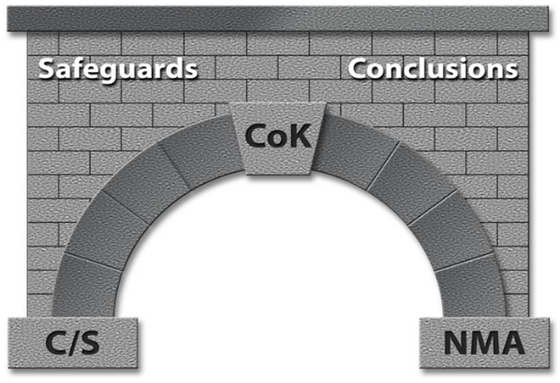

CoK is the Keystone for Drawing Safeguards Conclusions

Safeguards monitoring can be summarized as a need to understand a particular process. Every process contains an input and an output. It is our job and mission to characterize both, and to take into account that in some cases the understanding of the procedure to get from the input to the output is necessary. Consequently, the material balance equation becomes fundamental to our monitoring.

A process in safeguards is anything that has inputs and outputs. We then define Material Balance Areas or MBAs as distinct geographical areas where inventories can be performed (meaning where inputs and outputs can be measured and tracked). MBAs are typically actual physical processes, storage areas, shipments, etc... MBAs can be as large as an entire facility or as small as a source storage cabinet.

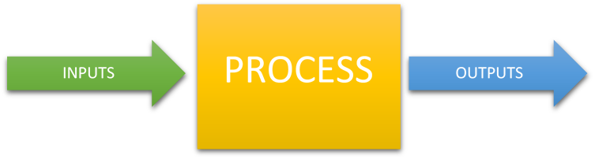

Deriving the Material Balance equation

In the depiction above illustrating a simple process; material enters, leaves, and may remain in a process. If all material that enters the process leaves the process, then:

Inputs = Outputs (ideal case)

If some material remains in the process from previous processing, then the inventory at a specific point in time will be:

Inputs = Outputs + Ending Inventory (EI) (EI is the material left in the process)

Thus, for the very first inventory period (beginning inventory n=0):

0 = Inputs – Outputs – Ending Inventory (EI)

At the second inventory at a point in time, the ending inventory of the first period becomes the beginning inventory (BI) of the second period, i.e. BI₂ = EI₁:

0 = Beginning Inventory₂ + Inputs₂ – Outputs₂ – Ending Inventory₂
0 = BI₂ + I₂ – O₂ – EI₂
Which leads to:
0 = BI_{n} + I _{n} – O_{n} – EI_{n}
or
0 = EI_{n-1} + I _{n} – O_{n} – EI_{n}
Where n is the n^{th} inventory period.

However, in nearly all nuclear material processes, each term is subject to uncertainty that is not perfectly known, therefore: we define the Inventory Difference (ID) or Material Unaccounted for (MUF) as:
ID = MUF = BI + I – O – EI (Material Balance Equation)

Note: Sometimes Inputs (I) and Outputs (O) are referred to as Additions (A) and Removals (R)

Unfortunately, most material balances at nuclear processing facilities are non-trivial. In these facilities, materials can change physical form and chemical composition as they are processed. These processes also result in process losses of material amounts that cannot be recovered for measurement (see figure below).

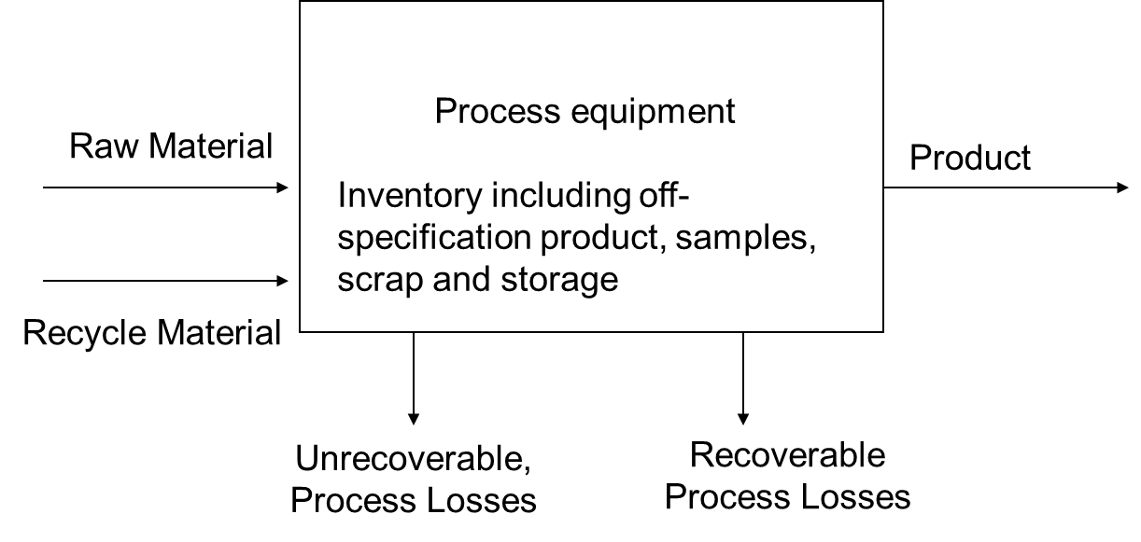

However, in most processes there is Material Unaccounted For (MUF). Our ability to determine MUFs is foundational for obtaining meaningful safeguards conclusions. Examples of things that contribute to MUFs are:

- Errors in the inventory
- Errors in the inventory process
- Process upset
- Human Errors
- Measurement Uncertainty
- Incorrect adjustments
- Unmeasured losses
- Theft/Diversion.

Even when all sources of contribution to MUF are minimized; there still are things that must be considered when drawing safeguards conclusions. These include:

- Prior knowledge: (What is the quality of past information? What do we know and what we not know?)
- Technical capabilities: (How good are the tools and methods? Do they compare with current methods?)
- Time (When was the information acquired? Could the material have changed since it was last measured?)
- Ability to monitor (Where can measurements be made?)

Many of these can be controlled with an effective measurement control program, documentation of calibration methods, standards, and meta-data, and maintaining effective C/S.

Since there are many contributors to MUF and ID it is very important in Safeguards that we ensure measurement uncertainty can be adequately quantified. When MUFs start to equal significant quantities of nuclear material; the effectiveness of Safeguard measures for detecting material diversion will be questioned.

Next, we will briefly discuss the DA and NDA measurement methods used for safeguards and the underlying nuclear data that is relied upon to accurately determine material types and amounts.

Destructive analysis for Material Control & Accountability (MC&A) and Safeguards

Destructive analyses (DA) are methods require obtaining a physical sample of the item for analyses. The obtained sample is typically “destroyed” as part of the analysis. The advantages of DA methods are high precision and accuracy, they are useful for the characterization of standards and allow for total analysis (potentially providing information on all actinides present). On the other hand, the disadvantages of these techniques are that they: require removal of material from the process, they are labor intensive and time consuming, subject to sampling errors, and they generate chemical, radiological and mixed waste.

In 2010, the International Atomic Energy Agency (IAEA) STR-368 established International Target Values (ITVs) for DA methodologies used for Uranium and Plutonium. The ITVs estimate the capability that could reasonable and realistically be expected from industrial-type laboratories on a routine basis.

Example of DA techniques include:

- Gravimetric Analysis: Where uranium tetrafluoride (UF₄) is converted to uranium oxide (U₃O₈) using pyrohydrolysis in a furnace at 850 °C
- Davies-Gray Uranium Titration: Chemical titration where Uranium (U) is reduced to U^{IV} then titrated to U^{VI}
- Coulometric Determination of Plutonium: Electrochemical “titration” where Plutonium (Pu) is oxidized from Pu^{III} to Pu^{IV}
- Mass Spectrometry: Thermal ionization mass spectrometry (TIMS) and isotope dilution mass spectrometry (IDMS) (These measurements are not absolute. The measurements are relative to an external (standard bracketing) or internal (isotope dilution) standard)
- X-ray Fluorescence: Can be used to quantify U in materials; may be considered an NDA method as well depending on how the sample is prepared.

It is important to mention that the uncertainty of most of the DA methods are limited to the instrumental measurement uncertainty and availability of suitable reference materials. In addition, DA methods depend on nuclear data, such as, atomic masses, half-lives, etc. One of the major safeguards needs in the area of destructive analysis is the ability to age date nuclear materials.

Nuclear Data Needs Presented:

- Consensus/improved half-lives for Th-229, Th-230 would benefit age dating of U materials
- For Pu determinations, IDMS and TIMS isotopic methods can benefit from consensus/improved half-lives for Pu-238, Pu-241, Am-241
- Age dating of Pu materials depends on the half-lives of Pu-241 and Am-241

Nuclear and Atomic Data Needs for Nondestructive Data Analysis (NDA) Measurements and Metrology in Nuclear Safeguards

From implementation to analysis and interpretation, NDA techniques depend on nuclear & atomic data. Nuclear and Atomic data are the utilized for:

- Design and optimization of measurement systems using forward predictive models
- Characterization and calibration of instruments
- Correction factors (to reference conditions), interference corrections
- Inverse analyses to determine source term using measurement data

Nuclear and atomic data uncertainties are often the limiting factors in the overall uncertainties achievable using an NDA technique. For accurate uncertainty quantification (UQ), it is important to consider covariances in nuclear data, but this is typically not done!

We often don’t use nuclear data as it was traditionally evaluated.
Minimizing systematic uncertainties due to nuclear and atomic data would improve the accuracies that can be achieved by the NDA instruments
Will in turn drive the revision of International Target Values (ITV) [see e.g. STR-368 (2010), ESARDA Bulletin 48 (2012)], resulting in better measurements.
The ITVs reflect the current state of practice, given the knowledge of the uncertainties (they are not a goal per se or what is possible).
We are obligated by IAEA agreements to use best metrological practices

- Fission Yields: Accurate estimation of neutron absorbing fission products is vital.
  - Build-up of neutron absorbing fission products, reduces the net neutron population inside and escaping from the source, and therefore, the count rate measured by an NDA instrument.
  - ORIGEN estimations of fission products such as ¹³³Cs, ¹⁴³Nd, ¹⁴⁹Sm, ¹⁵⁴Eu are within a few % of experimental values.
  - Absorption cross sections of some of the fission products (¹⁵⁵Gd) have relatively large uncertainties (~5.3%).
  - Calculated/Experimental ratios for ¹⁰⁹Ag, ¹⁰⁶Rh, and ¹²⁵Sb: 170%, 67%, and 100%, respectively.
  - Inconsistencies have been observed with respect to quoted uncertainties on legacy nuclear fission yield data on noble gas fission products; (e.g.) ⁸⁵Kr
- ²⁴⁴Cm is the dominant source of spontaneous fission neutrons as well as delayed neutrons from spent fuel: the nuclear data uncertainties are relatively high (8%).

Status of nuclear data and their uncertainties – Actinide reaction cross sections

- High-fidelity covariance matrices for evaluated ENDF/B-VII files are available for 3 major actinides, ^{235,238}U and ²³⁹Pu [P. Talou et al., Nuclear Data Sheets 112 (2011) 3054–3074]
- Covariance matrix evaluations for all major reaction cross sections are available- total, capture, fission, elastic, total inelastic, and (n,xn). [P. Talou et al., Nuclear Data Sheets 112 (2011) 3054–3074.]
  - Need: Angular distribution, uncertainties for discrete inelastic reaction cross sections
- Quotable quotes [P. Talou et al., Nuclear Data Sheets 112 (2011) 3054–3074]
  - “In many cases, the evaluation of the nuclear data was performed prior to the quantification of uncertainties, thereby creating a somewhat inconsistent approach.”
  - “While such detailed approach (for uncertainty quantification and covariance calculation) has been used for the standards evaluation, much less has been done for other reactions and isotopes.”
  - “The unresolved resonance region represents an interesting challenge…Such work would lead to correlations between the resolved resonance range and the fast energy range, which are totally absent from the current covariance matrices.”
- Fission cross sections: Important for source term definition and interpretation of the response of active and passive neutron NDA system measurements for safeguards (e.g. Active Well Coincidence Counter, Neutron Coincidence Collar).
- Neutron-induced fission cross section of ²³⁵U was evaluated by the IAEA Standards Group [A.D. Carlson et al., Nuclear Data Sheets, 110, 3215 (2009)],
  - ENDF/B-VII.0 evaluation incorporates their findings without modification, including the associated covariance matrix for this reaction
  - UQ for the neutron-induced fission cross-section of ²³⁵U is of major importance as most other actinide fission cross-section uncertainties are driven by it.
- Evaluation by the IAEA Standards Group is the result of major efforts from experts in the domain.
  - Yet, unrecognized correlations between experiments can be expected to lead to an underestimation of the final uncertainties.

Some Conclusions for NDA methods:

- Knowledge of nuclear and atomic data can become the limiting factors in design and calibration of NDA systems and physics-based modeling of responses from NDA systems used in safeguards applications.
- Among the nuclear data that are known very poorly are the neutron yields from (a, n) reaction on low Z nuclides.
- Uncertainty quantification, taking into account covariances, is needed for cross-section (fission and other reactions) data in the evaluated nuclear data libraries.
- Relative abundances of delayed neutron groups available in the literature have large uncertainties.
- Branching ratios of gamma-rays emitted by uranium, plutonium, and other actinide isotopes are needed with greater accuracies so that the uncertainties in the isotopic analyses can be driven down.
- Atomic data such as interaction cross sections and X-ray yield data have large uncertainties. These limit the accuracy of U and Pu elemental concentration results that are of importance to nuclear safeguards.

One of the main goals for safeguards is that the data should be independent of the instrument and it should be consistent throughout. For example, let us consider the power outputs.
If we are able to measure the heat that is being produced, then we will identify the material input at the beginning of the process.

DA and nondestructive data analysis (NDA) are for the most part complimentary techniques. In some instances, they can be interchangeable and in others, we rely more on DA measurements. For implementation of analysis and interpretation, NDA strongly depends on nuclear and atomic data, specially, decay data. Nuclear and atomic data uncertainties are often the limiting step of these analyses.

International Nuclear Safeguards and Nuclear Material Accounting and Control rest on accurate physical inventory measurements. In order to successfully carryout our mission, new measurements of the highest quality are necessary. Some of improvements can be made in:

- Fission Yields: Where accurate estimation of neutron absorbing fission products are vital.
- Fission Cross sections: Important source term definition and interpretation of the response of active and passive neutron NDA system.
- ²⁵²Cf Spontaneous fission: Should we adopt a small uncertainty even though nobody is able to measure it at that level?
- Beta-Delayed Neutron yields
- Laser-driven neutron source for research and global security
- Uncertainties in ²³³U data (branching ratios, gamma spectra, etc...)

Breakout Session Discussion Comments:

DA Nuclear Needs

Atomic masses are used in a variety of techniques such as mass spectrometry calculations. The uncertainty of these values is so small that is usually neglected. Most of the time these really well known values are treated as constants. However, there is ongoing discussions whether to continue to disregard these uncertainties.

Half-lives are very important when accounting for material. The short Half-lives of ²⁴¹Am, ²³⁸Pu and ²⁴¹Pu have uncertainties significant enough to have non-trivial effects on accountancy. A near-term goal for the safeguards community is to have consistent values of half-lives between national labs; it would be a useful first step. In addition, a literature review of the current state of use of such values could help us better understand the extent of the problem. It is also important to mention that ²⁴¹Pu has a string effect on measurements because it is used as a reference material.

Some important points to take into consideration when improving nuclear data are:
- Atomic clock is important to a number of programs.
- Improve data for ²⁴¹Am, ²³⁴U and ²³⁰Th. Special attention should be given to ²²⁹Th, since discussion about the value of its half-life still exists and it is currently being used as an IDMS tracer for age dating of uranium materials.
- The half-live of ²⁴¹Pu has direct impact in accountancy when propagating a measurement through time.
- A study on burn-up effects on fission product is needed. The yield of these products can be used for quantifying the number of fissions in a sample
_________________________________________________________________________

Nuclear Data needs for NDA

UF6 is the most abundant material in the fuel cycle. A 10% uncertainty can represent several significant quantities (SQs) of uncertainty in the MUF at the quantities of material handled in industrial facilities.

Need better (α,n) cross sections on low-Z material (e.g. F, O, N) in fuels. This also requires improvement of stopping power measurements and techniques since there is a need to understand the stopping of alphas in these materials. Interested in alpha energies of ~10 MeV down to threshold of relevant (α,n) reactions.

- See disagreements between Zeigler 77 and SRIM
- ¹³C (α,n) is important for calibration neutron detectors, improvements should be made
- This information is also relevant to astrophysical studies.
- This information is also relevant to molten salt reactor studies, low-Z isotopes found in F, Li, Be in other salts.
- A study on burn-up effects of fission products is needed. The yield of these products can be used for quantifying the number of fissions in a sample.

Intensity of γ emissions and branching ratios in the decay of ^{234m}Pa can have immediate impact on safeguards applications.
Delayed γ-ray spectra and models thereof are affected strongly by fission yields. These calculations are important for assay and safeguard applications.

- Both independent and cumulative fission yields
- For fissile materials and a variety of energy-group/energy-differential irradiations.
  - ²³⁵U, ²³⁸U, ²³⁹Pu, ²⁴¹Pu
  - For fast neutron spectra more fissionable isotopes become relevant
  - Carefully selected energy groups (like those that are currently standard in England and Rider libraries) can be useful to different applications because they can be selected/applied in an intuitive fashion.
  - Fast reactor design will need energy-differential yields because average energy groups will not be similar in different reactors.
- There are a number of active projects to measure fast neutron fission. However, low-energy neutron irradiations would likely require additional projects.
- High-energy gamma intensities for fission products.
- Identify high priority fission products for safeguards applications
  - Care in particular about less than 10 minute half-lives and gammas over 2.5 MeV
- Eventually it would be ideal to obtain fission yields for minor actinides as these are also found in spent fuel.

There are about 156 fission products. Not all of them contribute to the fission spectra. We are looking for high energy gammas. (¹⁴²La, Cm that is in spent fuel has a high cross section that causes some interference, ²³⁷Np, ²³³Pu)

A lot of work has been done in calculating data in a way that is useful maybe we need to go back to this libraries and pin point of what needs to be improved rather than starting from zero.

²⁵²Cf: Delayed neutron yields of ²⁵²Cf done at CARIBU to 1/10 of a second. We don’t know if it can get all extracted with the same efficiency or not.

New high-precision measurements of ²⁵²Cf (nu bar).

- Moments and distributions are desired but not as immediate of a need.
  - Evaluations of distributions need to be updated for applications like MCNP.

Use ⁶⁰Co for all the labs to calibrate their detectors. Gamma ray and K X-ray intensities of actinides (U and Pu high priority) and their daughter are necessary for NDA applications.

What is the real spontaneous fission rate to Cf and U (fraction of prompt vs. delayed)

We need separated isotopes 99%. We need our own data for own applications not the info that is in the library.

Are there methodologies discrepancy among labs? We probably need to make sure that all the labs have the same methodologies at the DOE level.

We are making corrections to effective neutron counter to about 2%.

Just like there are benchmarks for criticality, benchmarks are needed for safeguards.
We need to define what a bench mark for safeguards is.
What are the measurements of safeguard excellence?

Not just prompt neutron spectra but also prompt gamma spectra.

Evaluation of p of nu. Where can it be improved? MCNP and NJOY code development to facilitate transfer of new evaluations to processed code libraries.

Format for covariance matrices for neutron and gamma multiplicity distributions. This should be done in GNDS

Materials Damage and Gas Production Cross Sections
Facilitator: Catherine Romano, Rapporteur: A. Lewis

The goal of the materials damage session was to understand the state of the displacements per atom (dpa) cross section (sigma-dpa) and gas production cross section data, identify gaps and determine potential solutions. The sigma-dpa cross sections are reliant on theoretical models that relate dpa to fluence, so the state of the theoretical models, recent progress and proposed work were discussed. Dpa cannot be measured directly but in order to validate predictions of materials damage and gas production, materials samples must be irradiated in a neutron source or an ion beam followed by rigorous materials testing of strength, thermal conductivity and structure. This section will summarize the discussions of the attendees of the Materials Damage roadmapping session during WANDA followed by the suggested solutions and future work.

Session Summary

Programmatic Need
The ability to predict the long term structural integrity and thermal properties of structural materials exposed to high neutron flux environments is critical for the licensing and construction of fission and fusion reactors. The NRC is currently challenged with relicensing light water reactors (LWR) for sixty years of operation, and they must have confidence that the pressure vessel and concrete structure will not be weakened by continuous exposure to neutrons and gamma rays. A typical PWR operating for 40 years at a load factor of 0.8 will result in an end-of-life fluence of 3x10¹⁹ n/cm² and about 0.045 dpa in structural materials. Long term waste is another NRC concern where materials need to withstand centuries of irradiation damage, although at lower dose rates. The nuclear energy industry is designing advanced reactors which operate at higher temperatures than LWRs, have a harder neutron spectrum and will use new materials. They are very interested in materials damage research and gas production cross sections. One example of a new material challenge is understanding how graphite neutronics and mechanical properties change when exposed to high temperatures and irradiation damage. For new fuels, damage caused by gas production and fission fragments must be better understood.

For fusion reactors, materials damage is one of the top two programmatic priorities because confidence in structural materials reliability is required to prove the viability of fusion power. There is a need to understand displacement damage, gas production from (n,α) and (n,p) reactions and transmutation cross sections at neutron energies of 14 MeV. Gas production in fusion reactor materials is about two orders of magnitude higher than for fission reactors. There is a goal to construct and operate a Fusion Nuclear Science Facility by 2040 or 2050, and the calculated outer blanket first wall dpa per full power year is about 15, and the gas production (He and H) is over 800 appm illustrating the severity of the problem.

Sensitivity Studies
An ITER benchmark model was used by the University of Wisconsin Fusion Technology Institute to compare the dpa and He production using various FENDL-2.1 and -3.1, ENDF/B-VII.1 and -VIII.0, and mcplib84 photon cross section libraries. The differences between libraries in the structural materials dpa was 9%, and the He production was as high as 18% indicating that the cross sections induce large uncertainties in the determination of materials performance predictions.

Theoretical Calculations
Ultimately, the materials damage community would like a correlation parameter to predict material response after irradiation of a given time in a specific environment. The damage to a given material depends on several environmental parameters including neutron and gamma flux, neutron and gamma energy spectrum, transmutation cross sections and temperature. If correlation parameters can be identified, the results of one irradiation environment could then be correlated to a real world environment. The NRT-dpa standard, developed in 1975, relates the number of Frenkel pairs formed based on the energy transferred to the primary knock-on atom and describes damage caused at 0 K. It is a scaled radiation exposure measure relating exposure to primary damage from neutrons, and it is proportional to the radiation energy deposited per volume. However, it does not describe the changes in the materials properties needed to predict useful lifetimes.

An IAEA coordinated Collaborative Research Project (CRP) on Primary Radiation Damage (PRD) was started in 2012. They proposed a new “athermal recombination-corrected dpa” (arc-dpa) which corrects for annealing of defects in the recoil cascade based on molecular dynamics models to supplement the NRT-dpa. The expected output is a numerical database for NRT-dpa as well as gas production cross sections with uncertainties. The main issues to be addressed are listed as: primary knockout atoms (PKA) spectra, KERMA/damage energy/dpa, neutron and proton induced gas production, uncertainties and EXFOR compilation of the missing experimental data. A report has been submitted and is expected to be released soon. More information can be found here: https://www-nds.iaea.org/CRPdpa/.

As part of the Nuclear Energy Agency’s (NEA) Working Party on Multi-scale Modelling of Fuels and Structural Materials for Nuclear Systems (WPMM) an expert group was brought together to assess the models for primary radiation damage. Details on the physics of materials damage and calculations of NRT-dpa and arc-dpa are found in the Expert Group report from 2015 and at the website: https://www.oecd-nea.org/science/wpmm/expert_groups/prd.html#meetings .

EUROFUSION is a European Consortium established in 2014 to collaborate on fusion research. The United States integrates their research through the CRPs and NEA Working Parties mentioned above. The roadmap can be found here: https://www.euro-fusion.org/eurofusion/roadmap/

Irradiation Facilities and Materials Testing
Neutron irradiation of materials of interest are conducted in reactors, ion beams or 14 MeV neutron sources. For fusion applications, an attempt to correlate fission spectrum neutrons or ions to 14 MeV neutron irradiations is being made. However, to validate predictions, 14 MeV neutron irradiation up to 50 dpa in many materials is required to have confidence in materials properties predictions.

Current neutron irradiation facilities include the High Flux Isotope Reactor (HFIR) at Oak Ridge National Laboratory (ORNL) and Advanced Test Reactor (ATR) at Idaho National Laboratory. Reactor neutron irradiations have the advantage of simulating the real in-reactor environment and provide the necessary data for NRC licensing for fission reactor applications. They do not adequately simulate the temperatures and neutron energy required for most fusion applications.

Ion irradiation is conducted within the Ion Irradiation Chamber at the Argonne Tandem LINAC Accelerator System (ATLAS). Heavy ions at ATLAS are useful to simulate fission fragment effects in fuels and structural materials. The advantage of ion beam irradiation is that is produces a large amount of damage in materials within a short time span and can provide useful materials screening to select best performing materials under irradiation. The difficulty is that the dose rate effects are not well correlated to the lower dose rates in real applications. Additionally, the time and length (penetration depth) scaling effects are not well understood.

In Europe, 14 MeV neutron irradiations are being conducted at the Frascatti Neutron Generator which is a D-T neutron source providing 10^11 n/s. However, a much stronger 14 MeV neutron source must be constructed. The International Fusion Materials Irradiation Facility (IFMF) is proposed which would deliver 10¹⁸ n/m²-s through a Li(d,xn) reaction with an anticipated cost is over $1 billion. A Fusions Materials Neutron Source is proposed that would be a smaller 14 MeV neutron source and may be a solution that can deliver 10¹⁴ n/s while the IFMF is being developed.

Neutron Dosimetry
Neutron Dosimetry directly supports materials irradiations with neutrons by providing information on the neutron fluence and the energy spectrum of the flux. The code STAYSL_PNNL is typically used for the spectral unfolding for the HFIR and ATR irradiations which uses the IRDFF v1.05 nuclear data library. Additionally, the dosimetry measurements can correlate radiation damage effects between all types of irradiations including charged particle irradiations. There is a need to improve the cross sections contained in the IRDFF activation library for many of the dosimetry reactions. This fact is emphasized by the long list of dosimetry reaction evaluations included in the Nuclear Energy Agency Nuclear Data High Priority Request List: http://www.oecd-nea.org/dbdata/hprl/search.pl?vspqdos=on .

Physical and Mechanical Testing, Microstructural Analysis and Characterization
Post-irradiation testing of materials includes structural and physical property tests for tensile strength, impact, fatigue, and thermal and electrical conductivity tests. The microstructural analysis includes the characterization of atomic dislocations and examination of trapped gases. Materials testing labs exist at ORNL, UC Berkeley and ANL.

There is currently no standardization of methods and reporting, and there is no comprehensive database of irradiated materials. There are partial databases across the complex. The Nuclear Science User Facilities (NSUF) sponsors a database of irradiated materials irradiated in EBR-II and ATR called the Nuclear Fuels and Materials Library. They are currently looking for ways to expand this library. Through a recent project, a database was created of neutron irradiated FeCrAl Alloys.

Suggested Solutions and Proposed Work

- The construction of a 14 MeV neutron source is critical for fusion materials studies
- Review and conduct sensitivity/uncertainty studies of materials damage cross sections, gas production and transmutation cross section at neutron energies and on materials of interest!
  - Important for new fast reactors
- For materials damage
  - Most work has been done on Fe, Ni, Cr and other reactor materials. Materials such as W for fusion reactors have not been so well studied.
- For gas production:
  - Fe, Cr, Ni, W, Pb, C, Y, O, U (main structural or fuel elements), Ca (medical applications).
- Need to standardize post irradiation materials testing methods and data records
- SPECTR models
  - Need to include gamma induced displacements
- Calculations do not determine size of vacancies, and this is important for materials properties
- Processing of the data in NJOY needs a new look
  - There is currently a minimal threshold hard coded in that is not accurate for many materials
- ENDF is missing data for recoils and (n,α)
  - Need a review of the data
  - Inaccurate (n,α) data caused serious miscalculation of materials lifetimes
- Need to understand how changed materials properties change the neutronics
  - Transmutation
  - Porosity
  - Chemical bonds
- Propose to combine ion beam irradiation with positron beam to examine real time changes to understand the temperature and dose rate effects
- Need to create a well-documented irradiated materials database
  - EXFOR type database?
  - Extend the Nuclear Fuels and Materials Library at INL?
  - How do we establish quality control?
  - Need to standardize methods and reporting
- Support new improved data for the International Reactor Dosimetry and Fusion File (IRDFF) is missing some important reactions.

Nuclear Energy
Facilitator: B. T. Rearden, Rapporteur: E. Matthews

Introduction

Reliable modeling and simulation predictions of nuclear energy systems are essential to the design, licensing, and operation of nuclear power stations, as well as the fuel cycle facilities for enrichment and material processing, fuel fabrication, and transportation. Additional predictive calculations are required for spent fuel characterization for storage, transportation and disposal as well as hardware activation and radiation shielding and personnel protection. Nuclear data and their uncertainties provide the foundational physics for a wide range of calculations including:

- Reactor core and fuel design,
- Safety parameter assessment and transient analysis,
- Radionuclide and decay heat inventories for severe accident analysis,
- Criticality safety,
- Radiation shielding,
- Material damage in structures,
- Decay heat at reactor shut-down,
- Decay heat in storage and transportation,
- Mass flow in the fuel cycle, and
- Material safeguards.

The nuclear physics of these systems are inferred from neutron cross sections, fission spectra, neutron multiplicity, fission product yields, decay constants, branching ratios, gamma yields, delayed neutron precursors, and more. For light water reactors (LWRs), nuclear data have been used, tested, and often “tuned”, over many decades to provide acceptable results, and there is an abundance of documented benchmark quality experiments and plant operation data for the validation of common scenarios. However, for new applications such as fuels and materials in advanced reactors, accident tolerant fuels, high burnup fuel, and spent fuel repository scenarios, there are many needs to improve nuclear data and assess the availability of benchmark experiments that could be applied for testing and validation.

The generation and distribution of nuclear data, as well as the benchmarking of the performance of codes and data, is a global effort. In the US, nuclear data that is used to analyze fission systems are primarily generated by teams supported by DOE-NP and the NNSA, including the Nuclear Criticality Safety Program (NCSP). These teams collaborate through the Cross-Section Evaluation Working Group (CSEWG) to create and test the ENDF libraries prior to distribution. They advocate for improved performance applications of interest to their mission, but because nuclear energy interests are not well represented at the review meetings, the impact of updates to nuclear data and associated uncertainty information on nuclear energy applications is often overlooked.

Nuclear Data Tuning

For files included in the Evaluated Nuclear Data File (ENDF) library, nuclear data evaluations are produced by providing a best-fit representation of differential measurements. However, it is not the “goodness” of a particular fit to differential data that is used as a performance metric of the evaluation; the evaluation’s performance is measured against integral quantities of interest. For example, the performance of a new n+²³⁵U evaluation may be quantified by comparing the change in the ratio of computed-to-measured k_{eff} values for a series of evaluated benchmark experiments such as those compiled and maintained for the International Criticality Safety Benchmark Evaluation Project (ICSBEP). If the new evaluation does not produce computed results consistent with measured values, then the evaluator may change one or more parts of the evaluation within the differential measurement uncertainties to provide better agreement with the measured integral quantities. Unfortunately, this informed adjustment of the evaluated parameterization may lead to compensation of errors between reaction data sets for a particular isotope. In turn, this results in cross section data having cross correlations between isotopes.
One artifact of the nuclear data tuning process is a reduction in confidence in individual reaction parameters due to compensating errors. Where fission and capture reactions are modified to ensure that the integral value of k_{eff} is maintained, little confidence remains in the independent use of the fission cross section itself, which is essential to the prediction of reactor power distributions. These power distributions are essential to the prediction of peak fuel temperatures during a reactor transient to ensure that the fuel does not exceed thermal limits that are set to ensure fuel integrity. Reduced confidence in the fission cross section can have real consequences in the allowed power level and operating regimes for these systems.

Possible Impacts of ENDF/B-VIII.0 for Nuclear Energy Applications

The Nuclear Energy Agency (NEA) addresses the nuclear technology interests of its 33 member states. In the area of nuclear data, the Working Party on Evaluation Coordination (WPEC) established the Collaborative International Evaluated Library Organization (CIELO) Pilot Project (SG40) on worldwide nuclear data evaluation for the most important fission energy related materials. The CIELO isotopes include ¹H, ¹⁶O, ⁵⁶Fe, ²³⁵U, ²³⁸U, and ²³⁹Pu. The CIELO project led to many individual reactions on these nuclides being modified by huge percentages in ENDF/B-VIII.0 relative to ENDF/B-VII. Some examples of this are shown in Figure 1. Additionally, the neutron multiplicity (nubar) was also modified from ENDF/B-VII.0 to ENDF/B-VIII.0, with a comparison plot generated shown in
Figure 2.

These new, and very different, cross sections generally perform well for integral k_{eff} experiments from the ICSBEP, as demonstrated in validation studies. However, many individual reaction cross section have changed substantially, and their impact on reaction rates relied upon for safety and design calculations were not reviewed prior to the release of this new library.

Uncertainties provided with ENDF in the form of cross section covariance data are often not mature and may or may not represent the true uncertainty in the nuclear data. For the recent ENDF/B-VIII.0 release, the readme file provided by the NNDC provides a disclaimer warning against the use of covariance data without applying a sensitivity/uncertainty approach to adjust the uncertainties for application specific analysis using relevant benchmark experiments. This specialized process is generally not available to users and presents many complicated aspects even for experts in the field, leaving a large gap between data provided by nuclear data evaluators and those useful for application in safety and design calculations.

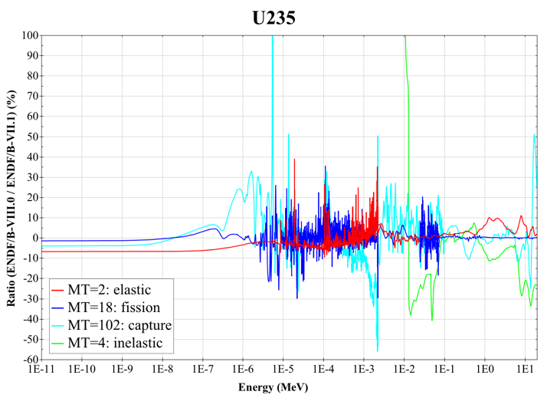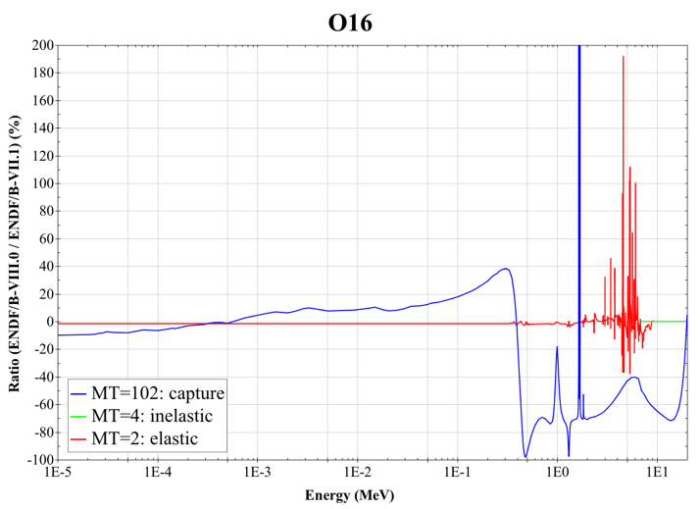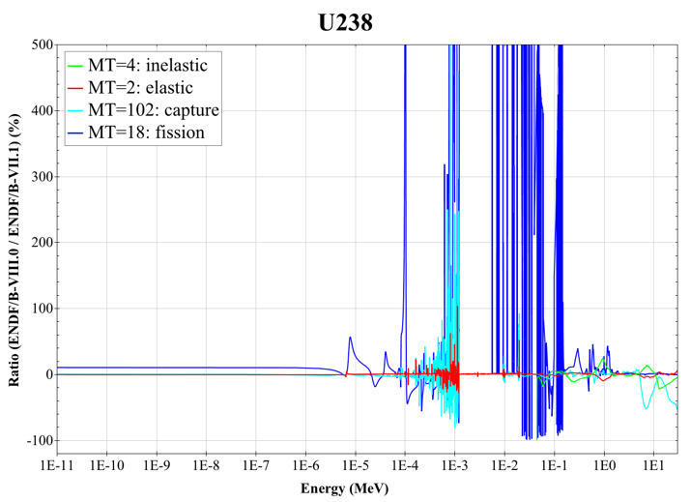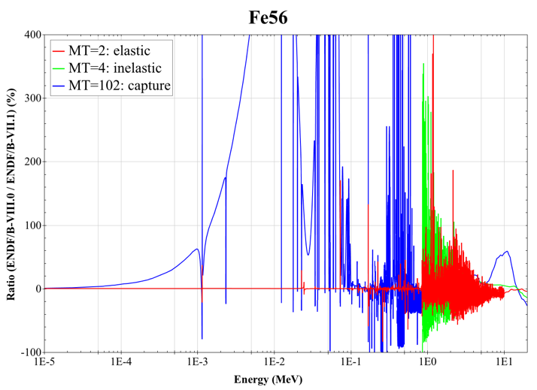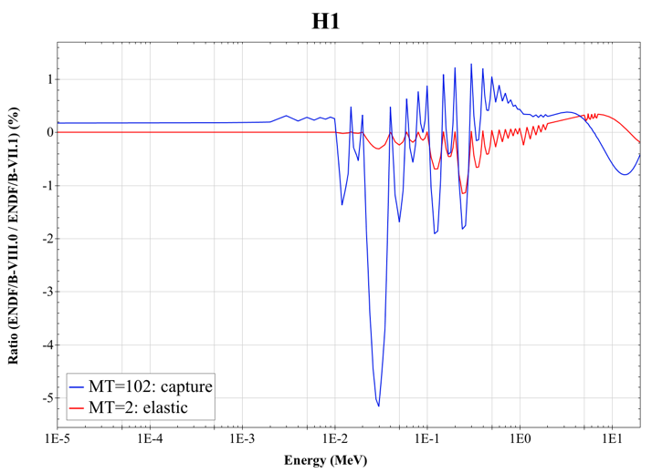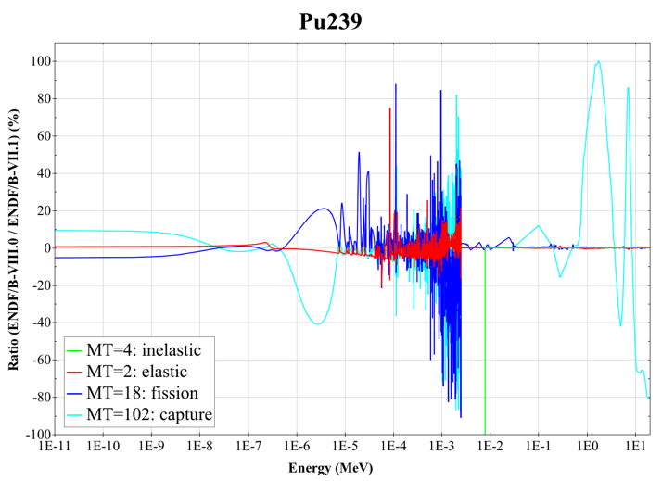
Figure 1. Ratio of cross sections of key nuclides from ENDF/B-VII.1 to ENDF/B-VIII.0.

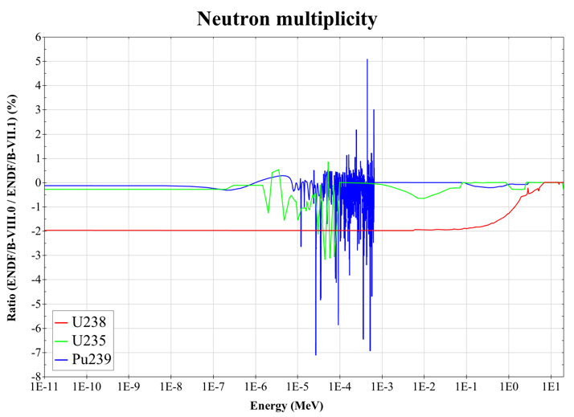
Figure 2. Ratio of neutron multiplicity of key nuclides from ENDF/B-VII.1 to ENDF/B-VIII.0.

Session Presentations

The technical content of this session was curated as follows:

- Nuclear data needs for regulatory review presented by Nuclear Regulatory Commission (NRC) technical staff including:
  - Fuel cycle, transportation, and storage, from the Office of Nuclear Materials Safety and Safeguards (NMSS)
  - Current LWR fleet support for the Office of Nuclear Reactor Regulation (NRR) and the Office of Nuclear Regulatory Research (RES)
  - Needs for advanced non-LWR reactors from the Office of New Reactors (NRO)
- Nuclear data needs for industry presented by management and technical staff including:
  - Hight Temperature Gas-cooled Reactors (HTGRs) (X-energy)
  - Sodium fast reactors (SFRs) and fast spectrum Molten Salt Reactors (MSRs) (TerraPower)
  - Lead fast reactors (LFRs), microreactors, and LWRs (Westinghouse)
- Nuclear data research presented by university professors and national laboratory technical staff including:
  - Fluoride salt-cooled High Temperature Reactors (FHRs) and MSRs (UC Berkeley)
  - Thermal scattering law data (N.C. State)
  - Target uncertainties (INL)
  - Approaches to improving covariance data (ORNL)

Common Themes

Throughout the presentations, several common themes emerged including the following.

Re-evaluation of nuclides important to nuclear energy applications, with an emphasis on data "tuning" beyond the typical k_{eff} responses, to ensure the accuracy of energy-dependent reactions in the predictive calculation of reactor power distributions, control rods worth, etc. are also encouraged. In particular, reviews of the ENDF/B-VIII.0 evaluations for ²³⁵U, ²³⁹Pu, ¹H, ¹⁶O, and ⁵⁶Fe are needed.

Cross section covariance data useful for application analysis that account for correlations introduced in that data "tuning" process are also needed for uncertainty quantification, assessment of similarity of benchmark experiments for validation, and determination of safety margins.

Without the decades of operating experience and data tuning that have been applied for LWRs, new nuclear data needs have been identified for design and operating analysis of advanced systems including SFRs, LFRs, HTGRs, liquid fueled MSRs, FHRs, and microreactors. The following nuclear data needs have been identified as possible limiting factors in the design, licensing and operation of these advanced systems, including the associated front end and back end fuel cycle facilities.

- Improving our knowledge of the ²³⁸U(n,n’)cross section. ²³⁸U(n,n’) is a limiting factor in the design of fast spectrum reactors such as those with metallic cores or chloride salts. The 40% uncertainty in this cross section in ENDF/B-VII.1 propagates to an uncertainty of 1.5% Δk in the criticality state of a sodium fast reactor (i.e. at the 2σ level, k_{eff} could range from 0.97 to 1.03 based on this uncertainty prediction).
- Improved knowledge of the ³⁵Cl(n,p) cross section. Changes from the 2006 release of ENDF/B-VII.0 to the 2011 release of ENDF/B-VII.1 are causing a 2-3% Δk change in reactivity in molten chloride salt fast reactors. This data change will also impact criticality analysis in salt repositories and there are no benchmark experiments available for validation.
- Graphite data for HTGR and FHR as well as the Transient Reactor Test Facility (TREAT) facility have realized a number of updates that cause dramatic changes in criticality. Updates from ENDF/B-VII.0 to ENDF/B-VII.1 lead to a 1% Δk change in reactivity for the High Temperature Engineering Test Reactor (HTTR), leading to the calculations better matching experimental values. Proposed updates to the graphite thermal scattering data for the ENDF/B-VIII.0 release have been demonstrated to cause a 2% Δk change in reactivity for the TREAT M8CAL benchmark.
- Thermal neutron scattering in molten salts, such as FLiBe. There are no cross-section data that represent the effect of the molecular bonds, leading to a computational bias of unknown magnitude in all reactor design calculations. The molecular bonds in water vs. Polyethylene can lead to a computation bias of 1-2% Δk. In addition, this effect is temperature dependent and is not well studied or understood. A recently developed benchmark experiment evaluation of the Molten Salt Reactor Experiment (MSRE) which consisted of uranium fuel FLiBe molten salt flowing through graphite channels demonstrates a bias of over 1% Δk from the experimental value, with other presented results showing biases over 3% Δk.
- (n,x) reactions on heavy actinides that will buildup in molten salt reactors and high burnup fuel are poorly quantified and benchmark data are rare, so these effects are almost completely unknown.
- Uncertainties provided with ENDF in the form of cross section covariance data are often not mature and may or may not represent the true uncertainty in the nuclear data. For the recent ENDF/B-VIII.0 release, the readme file provided by the National Nuclear Data Center (NNDC) provides a disclaimer warning against the use of covariance data without applying a sensitivity/uncertainty approach to adjust the uncertainties for application specific analysis using relevant benchmark experiments. This specialized process is generally not available to users and presents many complicated aspects even for experts in the field, leaving a large gap between data provided by nuclear data evaluators and those useful for application in safety and design calculations.
- Nuclear data are gathered from many different sources, not only ENDF but also the ENSDF as well as the Joint European Fission Fusion (JEFF) library, which often have differing representations of the same data. The process of sorting through the data to correct inconsistencies and benchmark the consolidated library against benchmark experiments is complex.
- Uncertainty data are not available or are incomplete for fission product yields, decay constants, and angular distributions, making it difficult to have high confidence in predicting the performance of advanced systems.
- Many of these advanced nuclear energy systems require so called high-assay low enriched uranium (HA-LEU), which has a ²³⁵U enrichment >5% and <20% by mass, were the current fleet of LWRs utilize enrichments of 5% or less. With few benchmark experiments in HA-LEU enrichment range, the interplay of the cross sections for multiple nuclei become important, especially for LEU experiments where ¹H, ¹⁶O, ²³⁵U, ²³⁸U and others are applied simultaneously in the calculation of the integral k_{eff} response. Because the widely varying nuclear data may not have been tuned to 20% enriched ²³⁵U, particular attention must be given to these systems.

Atomic/X-ray Florescence Data

Summary of the WANDA session on Atomic and XRF data
D. Brown (BNL) and M.-A. Descalle (LLNL)

Background
The ENDF/B library is the main source of nuclear transport data for general purpose codes like MCNP, Geant4, SCALE, FLUKA, and PHITS. It is also the main source of decay and fission product data for isotope inventory codes such as ORIGEN and CINDER. What many users don’t realize is that ENDF/B also provides the electro-atomic and photo-atomic collisional data for these codes as well as for electron/photon transport codes such as EGS, ITS, SCEPTRE, and PENELOPE. Clearly ENDF/B’s user base is large and extends beyond nuclear transport. This broader user base includes health physics, medical physics, radiation shielding, plasma physics, experimental particle and nuclear physics, astronomy, astrophysics and space science, and other users. It is worthwhile to note that radiation instrumentation R&D for fundamental and applied physics, engineering and industry largely relies on simulation and calculations of electromagnetic interactions, which are based – directly or indirectly – on atomic physics data libraries. In addition, ENDF/B provides spectroscopic data in the atomic_relaxation sublibrary consisting of X-Ray Florescence (XRF), Auger electron yields and other data for a variety of other applications, including medical isotopes, safeguards and basic science.

These three ENDF/B atomic sublibraries, for all of their utility, are essentially unsupported. They have been maintained for almost a decade by a single LLNL retired scientist (Red Cullen) for free. He provided the data in both the legacy ENDF format and in the LLNL in-house ENDL format. However, relying on a retiree volunteer work is not a sustainable or viable solution for a set of sublibraries so widely used. The recent release of ENDF/B-VIII.0 brought into focus many issues such as the lack of clear ownership and responsibility for the atomic sublibraries, which results in an inability to address the need of the broader user community or to take their feedback into account. At the very least, CSEWG needs a succession plan which includes a roadmap to bring these sublibraries up to the quality and currency standards we expect from the rest of the ENDF/B library.

Given this, a session on Atomic and XRF data was held at the WANDA meeting with several goals in mind:
- Identify both the data users and the developers of the atomic data sublibraries
- Identify the priority needs of the data users
- Begin the process of assembling a plan to address these needs
In the process of this workshop session, it became clear that the atomic data discussion is really only beginning. The ENDF/B data library only addresses the needs of part of the broader community and even identifying the broader community of users is a challenge.

Impact
Scattering data on atoms and atomic relaxation data impact many fields:
- Shielding applications – Health and space physics need detailed dose and damage data
- Medical physics – precision data are needed for established radiotherapy and medical imaging applications, where R&D is actively ongoing, as well as for emerging techniques, such as Auger therapy, micro- and nanodosimetry.
- Isotope production – Both to produce isotopes of medical need and to understand by-products
- Safeguards – X-Ray Fluorescence (XRF), x-ray transmission in support of non-destructive assay of nuclear materials
- Basic science – XRF, photo-electric edges (XANES) are commonly used at light sources for target characterization
- Connection to decay data – Auger electrons are a common by product of many nuclear decays
- Fusion – Electron and photon collision data are needed for correct modeling of plasma
- Experiment and detector development in both fundamental and applied physics – both detector design and understanding detector acceptances, efficiencies, etc. are heavily based on Monte Carlo simulation, in turn relying on physics data libraries. Atomic data libraries play a key role, since electromagnetic interactions determine detector observables (e.g. energy deposition).
- Cultural heritage – X-ray fluorescence and other non-invasive techniques based on electromagnetic interactions are well established in this domain.

Although all of these areas use the atomic data in ENDF/B, not all are aware of their reliance nor on how to improve the data for their specific applications (e.g. fusion). Other areas (users of Auger electrons) are well aware of deficits and have detailed data requests presented already in the Isotope Production session, particularly in the presentation by Roger Howell on Auger emitting therapeutic radionuclides.

We note that the vast majority of collisional data users interact with the atomic data through the Monte Carlo simulation codes that use the atomic data libraries, rather than with the data libraries directly. Their requirements and feedback are often addressed to the Monte Carlo code maintainers, although they actually concern the data libraries.

User Needs
We as a community are in the very early in the stages of discussions. That said, a few things are quite clear:
- The origin of the data must be known and documented. Data must be reproducible, e.g. the codes used to produce tabulations of theoretical calculations must be accessible, maintained and documented.
- Produced data must be validated against both integral and direct experimental measurements. Currently only limited validation against direct experimental data (e.g. cross section measurements) is done. What form integral data validation should take is unclear; critical issues are distinguishing the contributions to experimental observables from multiple physics processes and disentangling the effects due to physics data from other modeling features.
- Uncertainties are needed on nearly all quantities. Neither the legacy ENDF/B nor ENDL formats support uncertainties on any atomic data. Methods to determine uncertainties associated with theoretical data should be investigated.
- Detailed data needs are provided in the Isotope Production, Radiation Damage and Safeguards session writeups of this meeting.
- Additional data needs are likely to emerge as a broader user community is asked for input.

State of Data and Tasks to Address Needs

Theory
- Spectroscopic data is in relatively good shape and there is a strong spectroscopy group at NIST who can provide assistance in data production and/or evaluation.
- Collisional theory support has a bigger gap. There are several groups around the country who could provide this support (Auburn Univ., Drake Univ., Western Michigan Univ., LANL, LLNL, Univ. Nebraska Lincoln, others), none are actively engaged in the ENDF/B community.
Experiment
- The NIST spectroscopy group has extensive tools for characterizing atomic spectra and are regarded as world leaders.
- Our understanding of the atomic collisional data experimental capabilities is not well enough developed.
Evaluation
- What is state of the art? It is clear that ENDF/B-VIII.0 does not always include it.
- Collection of NIST and IAEA collisional databases, how complete are these with respect to user needs?
  - IAEA’s ALADDIN database for instance only has limited collection of materials and only those relevant for fusion applications
  - Various NIST collisional databases are comprehensive, but are no longer updated
  - Collisional data evaluation capability in US has waned. The ORNL fusion group was the long-time lead for this work, but it was disbanded in 2010.
- The NIST Atomic Spectra Database is continuously updated and improved, but ENDF/B’s atomic_relaxation sublibrary is not current with it. Furthermore, the NIST Atomic Spectra Database does not include any data on electrons emitted during Auger, Coster-Kronig, super Koster-Kronig, or interatomic Coulombic decay processes, leaving a substantial gap.
- The provenance of the ENDF/B libraries are not always clear and even when it is clear, information about the status of their validation is missing or incomplete.
Formatting
- ENDF and/or ENDL format is incomplete but at the same time is the primary source of atomic data form many users. The GNDS format is poised to replace both formats but it is not in general use.
Processing
- Processing of atomic data in the ENDF format using the NJOY code system is poorly understood.
- The FUDGE code system provides a processing pathway using the new GNDS format(s), but the GNDS APIs are not in general use and have limited support for atomic data.
Validation
- Who identifies the state of the art? Internationally, few groups are engaged in systematic validation effort, and the most extensive validation was conducted by Pia’s group at INFN.
- Some older data (e.g. Scofield’s) perform better than more recent calculations!
- In the development of the current ENDF/B collisional libraries, validation consisted of code-to-code or code-to-calculation comparisons. These could be useful for verification purposes at most, but they are devoid of any value for validation.
- Some basic data comparisons were published (Pia), but a substantial fraction of the current atomic data libraries still lacks direct validation, and assessment of the state of the art is incomplete.
- Integral data are needed, a limited set of data may be made available (Sandia)
- Several measurements of primitive quantities (e.g. cross sections) relevant to the validation of atomic data libraries are documented in the literature, but substantial effort is needed to retrieve, digitize and evaluate them, and to identify gaps in the available data that require new experiments.

Path Forward

- Workshop(s) on Atomic data & Validation must be organized:
  - Contacting broad community to compile existing models of experiments that could be used for validation. The three NNSA labs (LANL, LLNL and SNL) should be able to help.
  - Pia and Brown are planning to organize a session on data libraries at the IEEE NPSS 2019 (https://nssmic.ieee.org/2019/)
  - CSEWG should organize one or more side meeting(s) on atomic data to engage the user base and developers within the United States
  - The IAEA has been approached about organizing Technical or Consultants Meetings to address gaps in atomic data. Some of this is already in progress within the Nuclear Data Section’s Atomic and Molecular Data Unit and will continue.
- The CSEWG needs to expand to include more people with atomic physics backgrounds:
  - NIST atomic spectroscopy group(s)
  - Research groups working on electron-atom and photon-atom collisions, including academic groups and those at NNSA labs
  - Other experts in electromagnetic interactions and related data, addressing a wide range of energies and experimental requirements
  - Broader shielding community, including NASA and others interested in space physics, as well as those who support major nuclear facility health physics efforts
  - Medical physics community
  - Fusion and high energy density communities at e.g. LLNL, LANL, General Atomics and MIT
We comment that none of these communities are funded by the DOE’s Office of Science or NNSA, the traditional funders and developers of nuclear data in ENDF/B.

- Spectroscopic data (ENDF/B atomic_relaxation). There are some “simple” improvements to the library that should be made:
  - The original EADL radiative transition probabilities were based on Hartree-Fock calculations that should be updated/repeated.
  - The transition probabilities in EADL lack uncertainties and correlation matrices. As a result, it is very difficult to calculate X-ray and Auger electron intensity uncertainties, as well as to improve EADL incorporating newly measured data.
  - Early EADL have fluorescence yields of unknown origin, and these have been removed from current versions in ENDF format
    - Part of many additions in EADL with unknown origin
    - Multiple compilations exist, some are from experiments, need to know difference between them all
    - Recent evaluations have collected recent experimental measurements
- Collisional data (ENDF/B electro- and photo-atomic): Collisional data evaluation work has essentially stagnated in the US, leaving a large gap in capabilities. Regenerating US capabilities and expertise is essential if we are to ever update the ENDF/B libraries.
- The EXFOR library will need to adapt:
  - Hundreds/thousands of papers are available in NSR for x-ray/Auger/atomic data but have not been actively compiled into EXFOR: a systematic compilation of atomic data needs to start!
  - EXFOR can also in principle store some validation data if the experiments are small and well defined
  - An extension of the EXFOR reaction string coding may be needed to distinguish x-rays from gamma-rays.
  - NIST group develops bibliographic databases for atomic spectroscopy: https://www.nist.gov/pml/nist-atomic-spectra-bibliographic-databases.
  - Interaction with groups involved in validation tests is needed to ensure that the atomic data in EXFOR encode all the relevant information needed for this purpose
- The legacy ENDF format cannot support all the data required by users. The Generalized Nuclear Database Structure (GNDS) format(s) can meet these needs.
  - GNDS already supports all atomic data including covariances; evaluators need data to put in it!
  - Support for GNDS in application codes is still in its infancy. Only the LLNL APIs are in production and they only support photo-atomic data. The APIs for other codes (MCNP and SCALE) are still in development.
  - It is unclear what plans Sandia has for their in-house codes SCEPTRE and ITS with respect to GNDS.
  - Consider using 1-cos(𝜃) instead of cos(𝜃) to address ENDF precision issue
- In all of these tasks, international collaboration is essential! The IAEA has long worked to address the gaps in national nuclear data programs and has an active atomic data compilation project. INFN (Italy) develops two of the most well-known transport code systems in basic science, GEANT4 and FLUKA, and will play an important role in data validation.
- Other needs are detailed in the Isotope Production and Safeguards sessions of this workshop.

http://bang.berkeley.edu/events/ndnca
http://nndc.bnl.gov/ndrew
PE Koehler, JL Ullmann, AJ Couture, and SM Mosby, Proceeding of the 6th International Workshop on Compound Nuclear Reactions and Related Topics, 2018; LA-UR-18-31822
J.E. Escher, J.T. Burke, R.O. Hughes, N.D. Scielzo, R.J. Casperson, S. Ota, H.I. Park, A. Saastamoinen, and T.J. Ross, Phys. Rev. Lett. 121, 052501 (2018).
G. R. Odette and G. E Lucas, Embrittlement of Nuclear Reactor Pressure Vessels, JOM, 53 (7) (2001), pp 18-22
S.J. Zinkle and L.L. Snead, Designing Radiation Resistance in materials for Fusion Energy, Annu. Rev. Mater. Res. 44, 241-267 (2014). doi: 10.1146/annurev-matsci-070813-113627
A. Davis, UW, FED2018
M. Sawan, FENDL Neutronics Benchmark: Specifications for the calculational and shielding benchmark, INDC(NDS)-316, December 1994.
Sublet, et al., Neutron-induced Damage Simulations: Beyond Defect Production Cross-section Displacement per Atom and Iron-Based Metrics, (2019 submitted).
Kai Nordlund, Andrea E. Sand, Fredric Granberg, Steven J. Zinkle, Roger Stoller, Robert S. Averback, Tomoaki Suzudo, Lorenzo Malerba, Florian Banhart, William J. Weber, Francois Willaime, Sergei Dudarev, David Simeone, Primary Radiation Damage in Materials, NEA/NSC/DOC(2015)9.
M. Martone, M. Angelone, M. Pillon, The 14 MeV Frascati neutron generator, Journal of Nuclear Materials, Volumes 212–215, Part B, 1994, Pages 1661-1664.
James I. Cole, NSUF Fuels and Materials Library, INL/EXT-15-36345, September 2015.
Kevin G. Field, et al., Database on Performance of Neutron Irradiated FeCrAl Alloys, ORNL/TM-2016/335, July 2019.
D. A. Brown et al. 2018. “ENDF/B-VIII.0: The 8th Major Release of the Nuclear Reaction Data Library with CIELO-project Cross Sections, New Standards and Thermal Scattering Data,” Nuclear Data Sheets 148, pp. 1–142.
International Handbook of Evaluated Criticality Safety Benchmark Experiments, NEA/NSC/DOC(95)03, NEA Nuclear Science Committee (2016).
A. Holcomb, D. Wiarda, and W.J. Marshall, “ENDF/B-VIII.0 Testing With AMPX and SCALE,” Proceedings of NCSD 2017: Criticality Safety – pushing boundaries by modernizing and integrating data, methods, and regulations, Carlsbad, NM (2017).
N. Touran and J. Yang, "Sensitivities and Uncertainties Due to Nuclear Data in a Traveling Wave Reactor," Proceedings of the PHYSOR 2016 Meeting in Sun Valley, ID, May 2016.
Ayman I. Hawari, Yuwei Zhu, Jonathan L. Wormald, Cole A. Manring, Nina Colby Sorrell, “Thermal Neutron Scattering Law Data Evaluations for Nuclear Technology Applications,” Proceedings of the M&C 2017 Conference, Jeju Island, S. Korea, April 2017.
D. Shen, et, al, “Zero-Power Criticality Benchmark Evaluation of the Molten Salt Reactor Experiment,” In Proceeding of PHYSOR 2018, Cancun, Mexico, April 2018.
USNDP Collaboration, Nuclear Data Needs and Capabilities for Applications, BNL-108491-2015-IR, Brookhaven National Laboratory (2015).
B. T. Rearden, et al, “Initial Investigations of the Criticality Safety Validation Basis for HA-LEU Transportation,” Trans. Nucl. Soc., June 2019.

